ATTACHMENT-2
INFORMATION ABOUT THE REFEREE ALTIMETER

GENERAL INFORMATION ABOUT THE REFEREE ALTIMETER
The “Referee Altimeter”, developed by the Competition Committee, is an electronic system which accurately records the highest altitude value (at the apogee) reached by the competing team’s rocket during its flight. The referee altimeter will be handed over to the competing teams by the Competition Committee during the integration activities in Aksaray Hisar Firing Test Range. The mechanical connection interface of the referee altimeter is presented in this document.

REFEREE ALTIMETER CONNECTION INTERFACE
The Referee Altimeter has the dimensions as shown in Figure 1 and it will be given to the teams to be used as a single piece (assembled before). The altimeter has an interface to allow the users to integrate it into their own system, as shown in Figure 2. The teams can integrate the altimeter into their systems using fasteners such as M4 bolts (Figure 3) or plastic clamps (Figure 4).
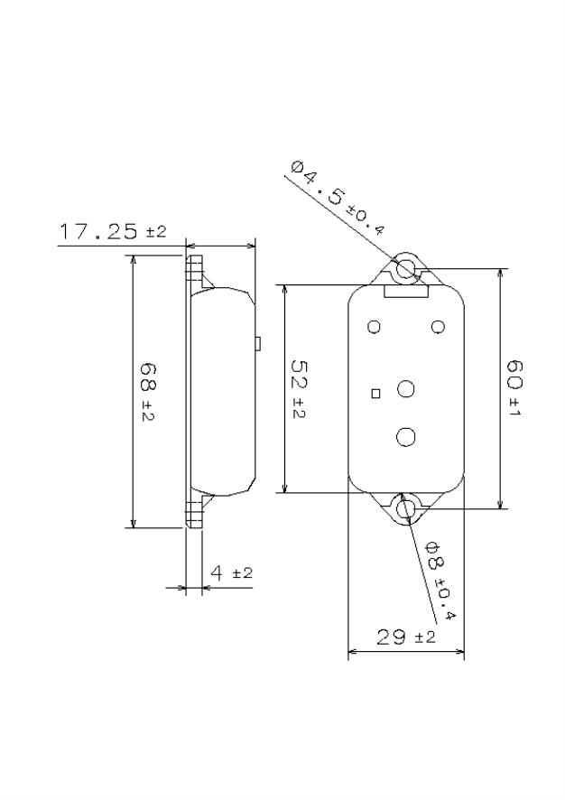
Referee Altimeter
Figure 1. Referee Altimeter
The On/Off Button is located on the Referee Altimeter as shown in Figure 2.
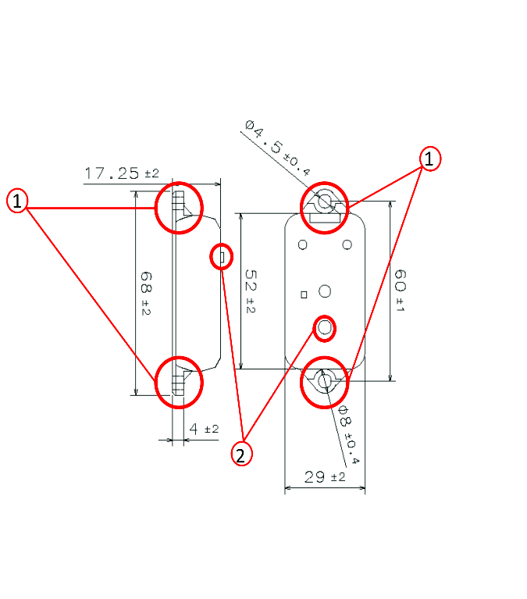
1. m3/m4 Bolt/Plastic Clamp Connection Interface
2. On/Off Button
Figure 2. Referee Altimeter Connection Interface and On/Off Button
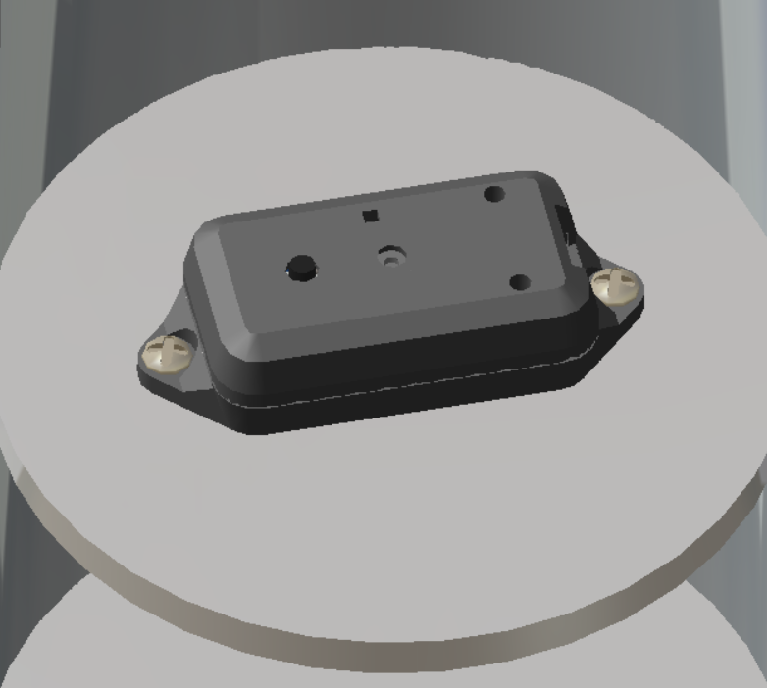
Figure 3. Referee Altimeter M4 Bolt Installation
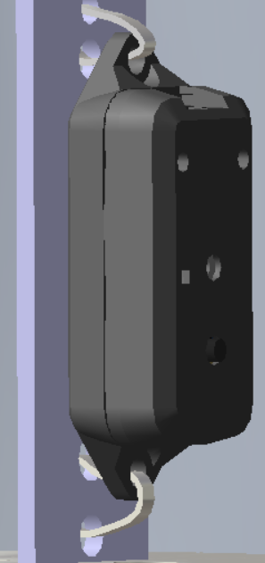
Figure 4. Referee Altimeter Plastic Clamp Installation

